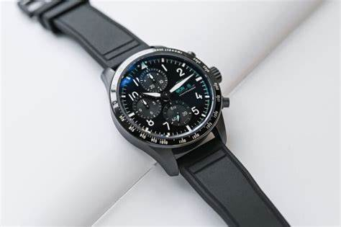**Prograce**

Description: **Prograce** is a brand known for its **kid-friendly smartwatches** that combine **fun, functionality, and safety**. Designed specifically for children, Prograce smartwatches offer a variety of engaging features, including **built-in cameras, music players, interactive games, and fitness tracking**. These watches provide a great alternative to smartphones, allowing kids to enjoy technology in a **safe and controlled way**.

One of the standout models is the **Prograce Kids Smartwatch**, which features a **touchscreen display, pedometer, flashlight, and an MP3 music player**. It also includes a **selfie camera with photo and video capabilities**, enabling kids to capture fun moments. Many models come with **pre-installed educational games**, helping children learn while staying entertained. Unlike smartwatches with SIM card functionality, most Prograce watches focus on **offline entertainment and activity tracking**, making them ideal for parents who want to limit screen time while still offering a fun tech experience.